AI SPORTS ACADEMY MANAGEMENT SYSTEM
An Intelligent Platform for Sports Academy Administration and Performance Analytics
A Project Based Learning Report Submitted in partial fulfilment of the requirements for the award of the degree
of
Bachelor of Technology
in The Department of Computer Science and Engineering
Database Engineering & Database Systems Design (DBE & DSD) – 25CS1302E
Submitted by
2510030153: RISHI VARDHAN REDDY
2510030021: M. SAI VARUN REDDY
2510030380: TIRUMALA NAIDU
2510030096: A.V. SAI CHAITANYA
2510030327: ANSHITH REDDY
Group – 9
Under the guidance of
Dr. RAFEEQ MOHAMMED

Department of Computer Science and Engineering
Koneru Lakshmaiah Education Foundation, Aziz Nagar
Aziz Nagar – 500075
Academic Year 2026–27 | OCT - 2026.

Abstract
Sports academies still manage player registrations, attendance, schedules, fees and performance records manually or with disconnected software. This fragments athlete data, consumes coaches' time in paperwork, and makes it hard to track player progress or to anticipate which athletes are falling behind. A review of six existing systems (S1–S6) covering event management, gym administration, sensor-based athlete monitoring, fitness-test scoring and intramural leagues showed that each addresses only one slice of the problem and that none unifies academy administration with performance analytics.
This report presents the AI Sports Academy Management System, a web-based platform that links athletes, coaches, batches, attendance, fees and performance through a single relational PostgreSQL schema with integrity constraints, and layers an AI performance-analytics service on top. The service derives attendance percentage, fee status and performance-trend features from the stored data, scores each athlete with a trend-based regression model, flags athletes as on-track or at-risk, recommends training focus areas and produces a prototype injury-risk estimate. Role-based React dashboards give the Admin, Coach and Athlete/Parent a real-time view, supported by a Python REST back end.
The working build was evaluated with eight functional test cases covering login, record creation, update and deletion, attendance, fee status, API communication and AI prediction; all eight passed, giving a 0% error rate. Performance measured as the average of 20 runs in Chromium gave a page load of 48 ms, login-to-dashboard of 67 ms and an add-player operation of 11 ms, with search under 0.1 ms. The results show that a carefully designed relational foundation can integrate administration and analytics on modest hardware. The report closes with limitations — validation on sample data, a prototype injury-risk module — and future work including online fee payment, parent notifications, a mobile app and wearable-sensor integration.
Keywords: Sports academy management, PostgreSQL, relational database design, AI performance prediction, injury-risk prediction, role-based dashboards, REST API, React.

List of Figures
Figure 1: Three-tier architecture of the proposed system 10
Figure 2: End-to-end data and processing workflow 11
Figure 3: Entity relationship overview (textual) 15
Figure 4: Request flow through the system 17
Figure 5: Project development phases 18
Figure 6: Login page 24
Figure 7: Home page – dashboard 25
Figure 8: Main application – Players 25
Figure 9: Forms – Add Player 26
Figure 10: Dashboard – AI Performance 26
Figure 11: Output – Injury Risk Prediction 27
Figure 12: Measured performance of the working build 28
Figure 13: Attendance and performance of the sample athletes 29

List of Tables
Table 1: Stakeholders affected by the problem 2
Table 2: Project scope across four dimensions 3
Table 3: Existing systems reviewed (S1–S6) 4
Table 4: Database technologies used in the reviewed systems 5
Table 5: Literature review matrix 5
Table 6: Gap analysis of existing approaches 6
Table 7: Critical review of S3 6
Table 8: Mapping of gaps to the proposed solution 7
Table 9: Problems identified and design responses 8
Table 10: Data collection methods 8
Table 11: Derived features used by the AI module 9
Table 12: Technology stack 10
Table 13: Hardware, software and data requirements 11
Table 14: How the proposed system differs from existing systems 12
Table 15: Functional requirements 13
Table 16: User roles and permissions 13
Table 17: Module design 14
Table 18: Relational schema (designed) 15
Table 19: Representative REST endpoint groups 16
Table 20: AI module outputs shown on the dashboard 17
Table 21: Development environment 18
Table 22: Module implementation summary 19
Table 23: Deployment plan 20
Table 24: Test levels 22
Table 25: Functional test cases 22
Table 26: Performance measurement set-up 22
Table 27: Sample athlete data shown in the working build 25
Table 28: Functional results 27
Table 29: Testing results 27
Table 30: Test summary 28
Table 31: Performance measurements 28
Table 32: Comparison of the proposed system with the reviewed systems 30
Table 33: Future scope 31
Table 34: Data dictionary – users 34
Table 35: Data dictionary – coaches 34
Table 36: Data dictionary – batches 34
Table 37: Data dictionary – athletes 34
Table 38: Data dictionary – training_sessions and attendance 35
Table 39: Data dictionary – fees, performance_tests and notifications 35
Table 40: Use case: Mark attendance 38
Table 41: Use case: Analyse athlete performance 38
Table 42: Use case: Register a new player 38
Table 43: Use case: View fee status 38
Table 44: Risk analysis and mitigation 39
Table 45: Project team (Group 9) 40
Table 46: Project review milestones 40

Table of Contents
1. Introduction 1
1.1 Background 1
1.2 Problem Statement 1
1.3 Why This Problem Matters 2
1.4 Societal and Industry Need 2
1.5 Project Objectives 2
1.6 Scope of the Project 3
1.7 Organisation of the Report 3
2. Literature Review 4
2.1 Purpose and Scope of the Review 4
2.2 Existing Systems Reviewed 4
2.3 Database Technologies Across Existing Systems 5
2.4 Comparative Analysis – Literature Review Matrix 5
2.5 Gap Analysis 6
2.6 Critical Review of a Key Study 6
2.7 Research Gap 7
2.8 How the Proposed System Addresses the Gap 7
3. Methodology 8
3.1 Problem Identification 8
3.2 Data Collection 8
3.3 Data Preprocessing 9
3.4 System Design – Architecture 9
3.5 Algorithm and Technology Selection 10
3.6 Workflow 11
3.7 Feasibility Analysis 11
3.8 Novelty of the Project 11
4. System Analysis and Design 13
4.1 Requirement Analysis 13
4.2 User Roles and Access 13
4.3 Module Design 14
4.4 Database Design 14
4.5 Application and API Design 16
4.6 AI Module Design 17
4.7 User Interface Design 17
5. Implementation 18
5.1 Development Environment 18
5.2 Project Development Approach 18
5.3 Frontend Implementation 19
5.4 Backend Implementation 19
5.5 Module Implementation 19
5.6 Security Implementation 20
5.7 Deployment 20
5.8 Maintenance Strategy 21
6. Experiments and Testing 22
6.1 Test Strategy 22
6.2 Functional Test Cases 22
6.3 Performance Measurement Set-up 22
6.4 Validation of the AI Module 23
7. Results and Analysis 24
7.1 Working Demonstration – Screens 24
7.2 Functional Results 27
7.3 Testing Results 27
7.4 Performance Analysis 28
7.5 Analysis of Results 29
7.6 Comparison with Existing Systems 30
7.7 Discussion 30
8. Conclusion and Future Work 31
8.1 Conclusion 31
8.2 Limitations 31
8.3 Future Work 31
8.4 Closing Remarks 32
References 33
Appendix A – Data Dictionary 34
Appendix B – Sample SQL Queries 36
Appendix C – Use Cases and Risk Analysis 38
Appendix D – Project Plan and Team 40
Appendix E – User Manual 41

1. Introduction

1.1 Background
Sports academies sit at the point where talent, discipline and administration meet. A modern academy enrols dozens or hundreds of athletes, groups them into age- and skill-based batches, assigns coaches to those batches, schedules training sessions, records who attended, collects monthly or quarterly fees, and periodically assesses how each athlete is progressing. Each of these activities generates data, and the quality of the academy's decisions depends directly on how well that data is stored, connected and analysed.
In practice, however, many academies still run these activities manually or with disconnected tools. Athlete profiles are kept in paper registers, attendance is marked on printed sheets, fee dues are tracked in a spreadsheet maintained by the accounts desk, and fitness test scores live in a coach's notebook. Because these records share no common keys, answering even a simple question — for example, "which athletes in the Under-16 cricket batch have attendance below 75% and an overdue fee?" — requires manually cross-checking several sources. The administrative workload grows with every new athlete, and coaches end up spending more time on paperwork than on training.
Parallel to this, artificial intelligence and data analytics have transformed elite sport. Wearable sensors, video analysis and machine-learning models are now used to monitor workload, estimate injury risk and predict performance. These capabilities, however, are rarely available to grassroots and mid-sized academies, partly because they require specialised hardware and partly because the data they need is not captured in a clean, structured form to begin with. A database-driven platform that first digitises the everyday academy data and then applies lightweight analytics to it can bridge that gap.
This report presents the AI Sports Academy Management System, a web-based platform developed by Group 9 as a Project Based Learning (PBL) assignment for the course 25CS1302E – Database Engineering and Database Systems Design (DBE & DSD) in the Department of Computer Science and Engineering, K L University, Hyderabad. The system integrates athlete management, coach and batch allocation, attendance, fee tracking, performance analytics and role-based dashboards on top of a single unified PostgreSQL schema, and adds an AI performance-prediction service that flags athletes as on-track or at-risk.

1.2 Problem Statement
Many sports academies still manage player registrations, attendance, schedules, fees and performance records manually or with disconnected software. This leads to the following concrete problems:
- Poor player record management — athlete details are scattered across registers and spreadsheets with duplicated or inconsistent entries.
- Time-consuming administrative work — coach–batch allocation, attendance consolidation and fee follow-up are repetitive manual tasks that are slow and error-prone at academy scale.
- Difficulty tracking player progress — test scores and attendance are recorded but never combined into a trend that a coach can act on.
- Lack of intelligent performance analysis — there is no mechanism to predict an athlete's improvement or to identify athletes who are slipping before the results show it.
- Inefficient communication among coaches, players and parents — there is no single place where dues, attendance alerts and progress are visible to the people who need them.
The problem therefore is not the absence of data but the absence of an integrated, structured and analysable data foundation for the academy. The project addresses this by designing one relational database that links every entity in the academy and by building services on top of it that automate administration and provide data-driven insight.

1.3 Why This Problem Matters
Manual management reduces operational efficiency: every hour a coach or administrator spends reconciling registers is an hour not spent on training or on athlete development. Player development itself is difficult without proper analytics, because improvement is a trend over weeks and months that cannot be seen from a single score or a single attendance sheet. Finally, the absence of transparency between academy and parents leads to avoidable disputes about fees and attendance.
The problem affects five groups of stakeholders, summarised in Table 1.
Table 1: Stakeholders affected by the problem
Stakeholder | How the problem affects them
Sports academies | Fragmented records, high administrative cost, difficulty scaling to more athletes and batches
Coaches | Time lost on paperwork; no objective view of athlete trends to plan training
Players (athletes) | Progress is not measured systematically; weaknesses are noticed late
Parents | Limited visibility of attendance, dues and progress; communication is informal
Academy administrators | Manual fee follow-up, allocation errors, no consolidated reports

1.4 Societal and Industry Need
The motivation for the project is both societal and industrial. Society benefits when more young athletes are supported by well-run, transparent academies that identify and nurture talent early. The sports-management industry benefits when routine administration is automated and coaching decisions become evidence-based. The specific needs identified are:
- Automate sports academy operations so that administrative effort does not grow linearly with the number of athletes.
- Improve coaching efficiency using AI by surfacing athletes who need attention.
- Provide real-time player performance insights through dashboards rather than end-of-term reports.
- Simplify attendance, fee and event management through a single digital workflow.
The beneficiaries are sports academies, coaches, players, parents and wider sports organisations. The expected societal and industry impact is a push toward digital transformation in sports management, a culture of data-driven coaching, better athlete development, reduced administrative workload and improved transparency between the academy and parents.

1.5 Project Objectives
The system aims to build one integrated platform that replaces disconnected registers and spreadsheets with a single PostgreSQL schema plus AI-driven performance insight. The specific objectives are:
- Unified database — design one relational PostgreSQL schema linking athletes, coaches, batches, attendance, fees and performance.
- Automate administration — digitise athlete onboarding, coach/batch allocation, attendance marking and fee tracking.
- AI performance prediction — score athlete trends from test scores and attendance, and flag on-track / at-risk athletes.
- Role-based dashboards — give the Admin, Coach and Athlete/Parent a real-time, access-controlled view of the data.
- Reports and decision support — generate attendance, fee and performance reports and personalised training recommendations.

1.6 Scope of the Project
The scope of the work covers the complete life-cycle of an academy's core operations, from requirement analysis and database design to implementation, testing and deployment of a working web application. Within scope are user authentication with role-based access, player management, coach management, attendance management, training schedule management, fee management, AI performance analytics, dashboards and reports, and a notification system. Hardware-dependent features such as wearable-sensor integration, and transactional features such as online fee payment, are deliberately placed outside the present scope and are discussed as future work in Chapter 8.
The application domain, data requirements, database technology and advanced requirements considered during the literature review are summarised in Table 2.
Table 2: Project scope across four dimensions
Dimension | Description
Application domain | Athlete onboarding, batch/coach allocation, attendance, fee and performance tracking in sports academies
Data requirements | Athlete profiles, attendance logs, performance/test scores, payments and coach–batch relationships
Database technology | Relational engines (MySQL, PostgreSQL, Oracle) and NoSQL/sensor-data stores used across reviewed systems; PostgreSQL chosen for this project
Advanced requirements | Predictive analytics for performance, real-time dashboards and scalable storage for sensor/training data

1.7 Organisation of the Report
The remainder of this report is organised as follows. Chapter 2 reviews six existing systems, compares them, and identifies the research gap. Chapter 3 describes the proposed methodology, including problem identification, data collection, preprocessing, architecture and algorithm selection. Chapter 4 presents the detailed system and database design. Chapter 5 describes the implementation, covering the development environment, modules, deployment and maintenance. Chapter 6 describes the experiments — the test strategy, test cases and performance measurement set-up. Chapter 7 presents the results and analysis, including working screens. Chapter 8 concludes the report and outlines future work, followed by the references.

2. Literature Review

2.1 Purpose and Scope of the Review
A literature review studies what already exists before a new system is designed. For this project it examines the applications built so far for sports and academy management, the databases and architectures behind them, and the limitations that leave room for improvement. The review was guided by five questions:
- What already exists in sports and academy management software?
- How were athlete, coach and attendance data modelled?
- Which databases were used, and why?
- What problems or limitations remain?
- What can our project improve?

2.2 Existing Systems Reviewed
Six studies were reviewed, covering sports and event management, gym administration, intramural systems and AI-based athlete-training platforms. They are labelled S1 to S6 throughout this report and are listed in Table 3.
Table 3: Existing systems reviewed (S1–S6)
ID | System | Database | Focus
S1 | College Sports Management System | MySQL | Coordinator-driven event registration, notifications and scheduling
S2 | Intelligent Sports Training System | MySQL | Deep-learning venue/equipment recommendation for college sports
S3 | Intelligent Sports Management System (ISMS) | PostgreSQL + MongoDB | Wireless sensor networks and neural networks for athlete performance
S4 | College Sports Performance System | MySQL | Digitised physical-fitness test scoring and statistical analysis
S5 | Gym Management System | MySQL | Membership, trainer assignment and workout-schedule tracking
S6 | Intramural Sport Management System | Oracle | Registration, scheduling and statistics for campus sports leagues

2.2.1 S1 – College Sports Management System
S1 is a coordinator-driven system for college sports. It handles event registration, notifications and scheduling on a MySQL back end. Its main advantage is a simple design that is easy for sports coordinators to adopt. Its limitation is that it does not track athlete performance: once a student is registered for an event, nothing about their subsequent training or progress is stored.

2.2.2 S2 – Intelligent Sports Training System
S2 applies deep learning to recommend venues and equipment for college sports and uses MySQL for storage. Its strength is personalised suggestions generated by the learning model. It does not, however, provide dedicated batch or coach management, so its recommendations are not connected to the organisational structure of an academy.

2.2.3 S3 – Intelligent Sports Management System (ISMS) using Wireless Sensor Networks
S3 is the most technically ambitious of the reviewed systems. It combines wireless sensor networks and neural networks for real-time athlete performance monitoring, storing structured athlete records in PostgreSQL and unstructured sensor data in MongoDB. It offers strong real-time performance analytics, but at the cost of heavier infrastructure, and it has no fee or administration module.

2.2.4 S4 – College Student Sports Performance Management System
S4 digitises physical-fitness test scoring and statistical analysis on MySQL. It reduces the manual, error-prone processing of test results, but it does not perform predictive or trend analysis over time; scores are recorded and summarised but not projected forward.

2.2.5 S5 – Gym Management System (NUTRIFLEX)
S5 is a gym-management website covering membership, trainer assignment and workout-schedule tracking, stored in MySQL. It provides centralised member and trainer records but has no link between attendance and performance and offers no analytics.

2.2.6 S6 – Intramural Sport Management System
S6 is an Oracle-based two/three-tier system for registration, scheduling and statistics for campus sports leagues. Oracle gives it reliable transactional consistency, but it has no AI or prediction capability and limited scalability.

2.3 Database Technologies Across Existing Systems
Table 4: Database technologies used in the reviewed systems
Database | Used by | Typical role
MySQL | S1, S2, S4, S5 | Registration data, event schedules, membership records, test scores
PostgreSQL + MongoDB | S3 | Structured athlete records (PostgreSQL) with sensor/unstructured data (MongoDB)
Oracle | S6 | Two/three-tier registration and league statistics for intramural sports

Observation. Relational databases (MySQL, Oracle) dominate the reviewed systems for transactional data such as registration, fees and schedules. Only one study (S3) combines a relational store with a document/sensor store for performance analytics. Most systems treat administration data and performance data as separate, unconnected concerns, which is exactly the fragmentation this project sets out to remove.

2.4 Comparative Analysis – Literature Review Matrix
Table 5: Literature review matrix
Study | DB | Main feature | Advantage | Limitation
S1 – College Sports Mgmt. | MySQL | Event registration and notifications | Simple, coordinator-friendly design | No athlete performance tracking
S2 – Intelligent Training Sys. | MySQL | AI-based equipment/venue recommendation | Personalised suggestions via deep learning | No dedicated batch/coach management
S3 – ISMS (Sensor Networks) | PostgreSQL + MongoDB | Athlete performance via sensors and neural nets | Strong real-time performance analytics | Heavier infrastructure; no fee/admin module
S4 – Performance Mgmt. Sys. | MySQL | Digitised fitness test scoring | Reduces manual, error-prone processing | No predictive or trend analysis
S5 – Gym Management Sys. | MySQL | Membership and trainer assignment | Centralised member/trainer records | No performance or attendance analytics
S6 – Intramural Sport Sys. | Oracle | League registration and statistics | Reliable transactional consistency | No AI/prediction; limited scalability

2.5 Gap Analysis
Mapping each reviewed approach to what it provides and what it lacks yields a clear set of gaps, shown in Table 6. Each row identifies a capability that is missing from that approach and which the proposed system must therefore supply.
Table 6: Gap analysis of existing approaches
Approach | Technology / DB | What it provides | Limitation | Identified gap
S1 – Event registration | MySQL | Registration, notices, schedules | No athlete or performance data | Athlete performance module missing
S2 – AI recommendation | MySQL | Equipment/venue suggestions | No batch or coach structure | Coach–batch allocation missing
S3 – Sensor-based ISMS | PostgreSQL + MongoDB | Real-time performance analytics | No admin/fee/attendance module | Unified admin + analytics missing
S4 – Fitness scoring | MySQL | Digitised test scores | No trend or prediction over time | Predictive performance tracking missing
S5 – Gym membership | MySQL | Member and trainer records | No performance/attendance link | Attendance–performance link missing

2.6 Critical Review of a Key Study
A summary describes what a study did; a critical review asks whether the approach was appropriate, whether the database choice suited the workload, and what remains untested. S3 was selected for critical review because it is the closest to this project in ambition. Its use of PostgreSQL together with MongoDB, wireless sensor networks and neural networks for real-time athlete performance monitoring is analysed in Table 7.
Table 7: Critical review of S3
Aspect | Critical observation
Strengths | ACID-compliant relational core plus a flexible document store; suited to real-time sensor throughput
Limitations | No coverage of academy administration — batches, coach allocation, attendance or fee collection
Evidence gap | Performance-analytics accuracy is not compared against a simpler, purely relational baseline
Possible improvement | Combine S3's analytics approach with an integrated relational schema for full academy operations

2.7 Research Gap
Based on the reviewed literature, existing systems primarily focus on either administrative record-keeping (registration, fees, membership) or isolated performance analytics, while limited work integrates both into a single, database-driven academy platform. Three specific observations support this conclusion:
- No reviewed system unifies athlete profiles, coach/batch allocation, attendance and fees in one schema.
- AI-based recommendation (S2) and sensor analytics (S3) are not combined with day-to-day academy administration.
- None of the systems offers predictive performance tracking tied directly to attendance and training history.
Overall gap. Existing studies treat academy administration and athlete performance analytics as separate systems built on different technologies. This justifies a single relational database (PostgreSQL) that links athletes, coaches, attendance, fees and AI-driven performance prediction.

2.8 How the Proposed System Addresses the Gap
Table 8: Mapping of gaps to the proposed solution
Proposed element | Description | Gap addressed
Unified schema | One relational database (PostgreSQL) links athletes, coaches, batches, attendance and fee records | Siloed designs in S1, S4 and S5
AI performance module | Performance-prediction logic inspired by S2 and S3, applied to structured attendance and training-history data rather than sensor data alone | No predictive tracking (S4); analytics detached from administration (S2, S3)
Real-time dashboards | Coach and admin dashboards show attendance, fee status and performance trends together | Combination absent from every reviewed study
Scalable foundation | Indexing, constraints and role-based access from the outset | Performance and security gaps noted across S1–S6

In summary, the literature review establishes that the novelty of the proposed work lies not in any single technology but in the integration of administration and analytics on one relational foundation.

3. Methodology
This chapter describes the proposed methodology, carried forward from the literature review: a unified PostgreSQL schema combined with an integrated AI performance-analytics layer. The methodology is presented in the order in which the work was carried out — problem identification, data collection, data preprocessing, system design, algorithm and technology selection, and the end-to-end workflow.

3.1 Problem Identification
Sports academies currently run athlete onboarding, coach/batch allocation, attendance, fees and performance tracking as disconnected activities. The literature review showed that every reviewed system (S1–S6) solves one slice of this problem, but none links administration and performance analytics in a single schema. Four concrete problems were identified and drive the design:
Table 9: Problems identified and design responses
# | Problem | Description | Design response
1 | Fragmented records | Athlete profiles, attendance, fees and performance scores are kept in separate registers or spreadsheets with no shared keys | Single relational schema with foreign keys
2 | No predictive insight | Test scores (S4) and sensor analytics (S3) are captured but never turned into a trend or forecast a coach can act on | AI trend-scoring service
3 | Manual admin overhead | Coach–batch allocation and fee follow-up (as in S1, S5) are done manually, which is slow and error-prone | Automated allocation, attendance and fee modules
4 | No unified dashboard | Admins and coaches have no single real-time view combining attendance, fee status and performance | Role-based dashboards

3.2 Data Collection

3.2.1 Sources of data
The data required by the system originates from the normal day-to-day operation of an academy. Five sources were identified:
- Athlete registration and profile forms (personal details, sport, batch preference).
- Attendance registers digitised at each training session.
- Coach and batch scheduling records maintained by admin staff.
- Fee payment and due records from academy accounts.
- Performance and fitness test scores recorded periodically by coaches.

3.2.2 Methods used to gather data
Table 10: Data collection methods
Method | Description
Structured web forms | Registration, attendance marking and fee entry captured directly through the application's dashboards — the primary live data feed
CSV / bulk import | Existing academy registers imported once during set-up to seed athlete, coach and fee history
Manual entry by coaches | Performance/test scores entered after each assessment session, tied to athlete and batch IDs
Sample / synthetic datasets | Used to prototype and validate the AI performance-prediction module before enough real history accumulates

3.2.3 Self-collected and public datasets
The project relies primarily on a self-collected dataset made up of player information, attendance records, training sessions, match statistics and fitness scores. Public datasets — the Kaggle Sports Performance Dataset, the FIFA Player Dataset and general athlete-performance datasets — are listed as optional sources that can be used to pre-train or sanity-check the prediction logic. Because the academy's own history is small at the start, sample data was used to prototype the working build.

3.3 Data Preprocessing
Raw data entered by humans is rarely clean. Preprocessing is therefore performed both at the point of entry (through validation and constraints) and before model training (through cleaning and feature extraction).

3.3.1 Data cleaning
- Deduplicate athlete and coach records on registration ID.
- Standardise date formats across attendance and fee-due fields.
- Validate mandatory fields (name, batch, contact) at entry time.

3.3.2 Handling missing values
- Flag incomplete attendance entries for coach confirmation.
- Use the last-known or mean value to fill gaps in test-score history.
- Mark optional profile fields nullable rather than forcing bad data.

3.3.3 Feature extraction and selection
Three families of features are derived from the cleaned data. Attendance percentage is computed per athlete per batch cycle as the number of sessions attended divided by the number of sessions scheduled. Fee-payment status is encoded as on-time or overdue. Performance-trend features are built from sequential test scores, capturing both the current level and the direction of change.
Table 11: Derived features used by the AI module
Feature | Derived from | Purpose
Attendance % | Sessions attended ÷ sessions scheduled, per athlete per batch cycle | Consistency indicator; strong correlate of improvement
Fee status | Paid / overdue flag from the fee table | Administrative risk indicator for dashboards
Current performance score | Latest test score per athlete | Current level
Performance trend | Slope of sequential test scores over the chosen window (e.g., last 6 months) | Direction and speed of improvement

3.4 System Design – Architecture
A single PostgreSQL database links every module, replacing the siloed designs seen across S1, S4 and S5, and feeds a dedicated AI performance-analytics layer. The architecture is organised into three tiers, shown in Figure 1.

PRESENTATION LAYER
Admin Dashboard · Coach Dashboard · Athlete / Parent Portal · Auth & Role Access
APPLICATION / API LAYER
REST API Layer (Backend Services) · AI Performance-Prediction Service
DATA & ANALYTICS LAYER
PostgreSQL — Unified Relational Schema
OUTPUT
Reporting / Real-Time Dashboards
Figure 1: Three-tier architecture of the proposed system
The modules — Athlete Management, Coach & Batch Allocation, Attendance, Fee Management, Performance Analytics (AI), and Dashboard & Reporting — all interact through the shared API layer and one PostgreSQL schema rather than through isolated stores. This is the central architectural difference from the reviewed systems.

3.5 Algorithm and Technology Selection

3.5.1 AI / ML approach
The AI module uses a trend-based regression model that scores athlete performance from sequential test scores and attendance history. No sensor hardware is required, unlike S3. The approach is inspired by S2's recommendation logic and S3's analytics but is applied to the structured administrative data that the system already captures. The module produces two outputs per athlete: a numeric trend score for dashboards, and a classification flag (on-track or at-risk) to support coach decisions. The model is retrained periodically as new attendance and test-score data accumulates in PostgreSQL.
In addition to performance prediction, the build includes a prototype injury-risk module which estimates risk from workload and performance indicators, and a recommendation module that suggests drills for identified weaknesses. These three are the "suggested AI features" of the project: AI performance prediction, a training-recommendation engine and injury-risk prediction.

3.5.2 Software tools and frameworks
Table 12: Technology stack
Layer | Technology | Role
Language | Python 3, JavaScript | Python for backend and AI; JavaScript for the frontend
Frontend | React.js, Chart.js | Role-based dashboards and charts
Backend | Django / Flask (FastAPI considered) REST API | Endpoints for each module and the prediction service
Database | PostgreSQL (MongoDB considered for sensor data) | Unified relational schema
ML libraries | Pandas, scikit-learn (TensorFlow considered) | Feature engineering and model training
Tooling | VS Code, Git / GitHub, Jupyter Notebook | Development, version control and experimentation

3.5.3 Justification of PostgreSQL
PostgreSQL was chosen over plain MySQL for two reasons. First, it supports JSON columns, which are useful for semi-structured performance data such as differing test batteries for different sports. Second, it offers strong relational integrity — foreign keys, check constraints, transactions — which is what links athletes, coaches, attendance and fees reliably. Python was chosen so that the machine-learning pipeline and the backend can share one ecosystem and one set of data-access code.

3.6 Workflow
The end-to-end workflow has six stages, shown in Figure 2: input data, preprocessing, feature extraction, model/system processing, output generation and evaluation.

1 Input Data  Attendance, fees, test scores, profiles | → | 2 Preprocessing  Clean, deduplicate, handle missing values | → | 3 Feature Extraction  Attendance %, fee status, score trends | → | 4 Processing  AI performance-prediction service | → | 5 Output  Dashboards and alerts | → | 6 Evaluation  Predictions vs actual outcomes
Figure 2: End-to-end data and processing workflow
As an example, an athlete's weekly attendance and monthly test score feed the model; the dashboard flags a dip in the trend before it shows up in results, and coaches evaluate the flag against real outcomes each cycle.

3.7 Feasibility Analysis
The feasibility of the project was assessed across hardware, software and data. The hardware requirement is modest: a laptop or desktop with an internet connection, with a camera and mobile device as optional extras. The software requirement is met entirely with open-source tools. The data requirement is met by self-collected data supplemented by optional public datasets. Table 13 summarises the requirements.
Table 13: Hardware, software and data requirements
Category | Requirements
Hardware | Laptop / desktop; internet connection; camera (optional); mobile device (optional)
Software | Python, JavaScript; VS Code, Jupyter Notebook; React.js, Flask / FastAPI; PostgreSQL, MongoDB; TensorFlow / scikit-learn; OpenCV (optional), Chart.js
Self-collected data | Player information, attendance records, training sessions, match statistics, fitness scores
Public data (optional) | Kaggle Sports Performance Dataset, FIFA Player Dataset, Athlete Performance Dataset

3.8 Novelty of the Project
Unlike traditional sports-academy management systems, this project integrates artificial intelligence for intelligent player analysis and decision support. Three features are novel in the context of the reviewed systems: AI player-performance prediction based on training and match performance; personalised training recommendations that suggest customised improvement plans for each athlete; and a smart performance dashboard giving real-time visualisation of growth, attendance, fitness and achievements.
Table 14: How the proposed system differs from existing systems
Existing systems | AI Sports Academy Management System
Manual performance tracking | AI-based performance prediction
Basic attendance records | Intelligent attendance analytics
Static reports | Interactive dashboards
General coaching | Personalised AI recommendations
Manual decision-making | Data-driven coaching insights

4. System Analysis and Design
This chapter converts the methodology into a concrete design: requirements, user roles, module decomposition, the relational database schema, the application interfaces and the design of the AI service. The database design is presented in detail because the project is, at its core, a database-engineering exercise. Table and column names given here describe the designed schema; the same entities appear in the working build.

4.1 Requirement Analysis

4.1.1 Functional requirements
Table 15: Functional requirements
ID | Requirement | Module
FR1 | Users shall register and log in with a role (Admin, Coach, Athlete/Parent) | Authentication
FR2 | Admin shall add, update, search, filter and delete athlete records | Player management
FR3 | Admin shall add and manage coaches and assign them to batches | Coach management
FR4 | Coaches shall mark attendance per batch per session | Attendance
FR5 | The system shall maintain a training schedule for each batch | Training schedule
FR6 | The system shall record fee dues and payments and show paid/overdue status | Fee management
FR7 | The system shall compute a performance trend score and an on-track / at-risk flag per athlete | AI analytics
FR8 | The system shall recommend training focus areas based on weaknesses | AI analytics
FR9 | The system shall estimate injury risk from workload and performance indicators | AI analytics
FR10 | The system shall present dashboards and generate attendance, fee and performance reports | Dashboard and reports
FR11 | The system shall notify users of low attendance, pending fees and completed payments | Notifications

4.1.2 Non-functional requirements
- Performance — every interaction should respond well under a second.
- Integrity — records of athletes, batches, attendance and fees must remain mutually consistent (enforced by database constraints).
- Security — role-based access so that each user sees only the modules and data relevant to them.
- Usability — a clean, single-page dashboard with search, filters and forms.
- Maintainability — versioned schema migrations, backups and periodic model retraining.
- Scalability — indexing and constraints in place from the outset.

4.2 User Roles and Access
Table 16: User roles and permissions
Role | Primary responsibilities | Access
Admin | Manage athletes, coaches, batches, fees, reports and settings | All modules
Coach | Mark attendance, enter test scores, view athlete trends and AI flags for assigned batches | Attendance, training, performance, injury risk, reports (own batches)
Athlete / Parent | View own attendance, fee status, performance and recommendations; receive notifications | Read-only access to own data

4.3 Module Design
The system is decomposed into nine main modules. Each module owns a set of tables and exposes a set of REST endpoints, but all of them share the same database and authentication service.
Table 17: Module design
Module | Function
User Authentication | Registration, login, role selection, session handling
Player Management | Register players and manage profiles; search and filter by sport, batch and status
Coach Management | Maintain coach records and their specialisations
Attendance Management | Daily attendance capture and tracking per batch; attendance percentage
Training Schedule Management | Define sessions per batch with time and venue
Fee Management | Fee tracking, payment status and reminders
AI Performance Analytics | Predictive performance scoring, at-risk flag, recommendations and injury-risk estimate
Dashboard and Reports | Real-time visual reports for admin, coach and athlete views
Notification System | Alerts such as low attendance and fee events

4.4 Database Design

4.4.1 Entities and relationships
The conceptual model identifies the following core entities: User, Athlete, Coach, Batch, TrainingSession, Attendance, Fee, PerformanceTest and Notification. The key relationships are:
- A Coach is assigned to one or more Batches; a Batch has exactly one primary coach at a time (one-to-many from Coach to Batch).
- An Athlete belongs to one Batch at a time (one-to-many from Batch to Athlete).
- A Batch has many TrainingSessions; each session generates one Attendance row per athlete in the batch (Athlete × Session is many-to-many resolved by Attendance).
- An Athlete has many Fee records (one per billing cycle) and many PerformanceTest records (one per assessment).
- A User account maps to an Admin, a Coach or an Athlete/Parent and receives many Notifications.

COACH (coach_id, name, specialisation, contact)
1 ── N BATCH
BATCH (batch_id, name, sport, age_group, coach_id)
1 ── N ATHLETE · 1 ── N TRAINING_SESSION
ATHLETE (athlete_id, name, age, sport, batch_id, status)
1 ── N FEE · 1 ── N PERFORMANCE_TEST · 1 ── N ATTENDANCE
TRAINING_SESSION (session_id, batch_id, date, time, venue)
1 ── N ATTENDANCE
ATTENDANCE (athlete_id, session_id, status)
resolves Athlete × Session (M:N)
Figure 3: Entity relationship overview (textual)

4.4.2 Relational schema
The conceptual model is mapped to the relational schema in Table 18. Primary keys are underlined conceptually by the "PK" tag and foreign keys by "FK".
Table 18: Relational schema (designed)
Table | Columns | Keys and constraints
users | user_id, username, password_hash, role, created_at | PK user_id; username UNIQUE; role CHECK in (admin, coach, athlete)
coaches | coach_id, user_id, name, specialisation, contact | PK coach_id; FK user_id → users
batches | batch_id, name, sport, age_group, coach_id | PK batch_id; FK coach_id → coaches
athletes | athlete_id, user_id, name, age, sport, batch_id, status, contact | PK athlete_id; FK batch_id → batches; age CHECK > 0; name/batch NOT NULL
training_sessions | session_id, batch_id, session_date, start_time, venue | PK session_id; FK batch_id → batches
attendance | athlete_id, session_id, status | PK (athlete_id, session_id); FKs to athletes and training_sessions; status CHECK in (present, absent)
fees | fee_id, athlete_id, due_date, amount, paid_on, status | PK fee_id; FK athlete_id → athletes; amount CHECK ≥ 0; status CHECK in (paid, pending, overdue)
performance_tests | test_id, athlete_id, test_date, score, details (JSONB) | PK test_id; FK athlete_id → athletes; score CHECK between 0 and 100
notifications | notif_id, user_id, message, created_at, is_read | PK notif_id; FK user_id → users

4.4.3 Sample DDL
The following excerpt shows how integrity constraints are expressed in PostgreSQL for three of the tables.
CREATE TABLE batches (
batch_id SERIAL PRIMARY KEY,
name VARCHAR(60) NOT NULL,
sport VARCHAR(40) NOT NULL,
age_group VARCHAR(20),
coach_id INT REFERENCES coaches(coach_id)
);

CREATE TABLE athletes (
athlete_id SERIAL PRIMARY KEY,
name VARCHAR(80) NOT NULL,
age INT CHECK (age > 0),
sport VARCHAR(40) NOT NULL,
batch_id INT NOT NULL REFERENCES batches(batch_id),
status VARCHAR(10) DEFAULT 'Active'
);

CREATE TABLE attendance (
athlete_id INT REFERENCES athletes(athlete_id),
session_id INT REFERENCES training_sessions(session_id),
status VARCHAR(8) CHECK (status IN ('present','absent')),
PRIMARY KEY (athlete_id, session_id)
);

4.4.4 Normalisation
The schema is designed to Third Normal Form (3NF). Every non-key attribute depends on the key, the whole key and nothing but the key. Athlete details are stored once in athletes and referenced by key elsewhere; batch details are stored once in batches; the many-to-many relationship between athletes and sessions is resolved by the attendance table with a composite key. Derived values such as attendance percentage and fee status are computed from base rows (or exposed through views) rather than stored redundantly, which removes update anomalies when a single attendance row changes.

4.4.5 Indexes and views
Indexes are placed on foreign-key columns that appear in joins and filters — athletes.batch_id, attendance.athlete_id, fees.athlete_id and performance_tests.athlete_id — so that the batch-wise lists, search and filter operations used by the dashboards remain fast as data grows. Two views are defined for reporting: an attendance-percentage view (per athlete per batch) and a fee-status view (paid, pending and overdue totals). These feed both the dashboards and the feature extraction for the AI module.
CREATE VIEW v_attendance_pct AS
SELECT a.athlete_id,
ROUND(100.0 * SUM((a.status = 'present')::int) / COUNT(*), 1) AS attendance_pct
FROM attendance a
GROUP BY a.athlete_id;

4.5 Application and API Design
The frontend communicates with the backend exclusively through REST endpoints. Each module exposes the standard create–read–update–delete operations over its resource, plus a small number of analytical endpoints. Table 19 lists the representative endpoint groups.
Table 19: Representative REST endpoint groups
Resource | Method(s) | Purpose
/auth/login, /auth/register | POST | Authenticate and create accounts; return role-scoped session
/players | GET, POST, PUT, DELETE | List (with search and filter), add, update, delete athletes
/coaches | GET, POST, PUT, DELETE | Manage coach records
/attendance | GET, POST | Mark and retrieve attendance per batch/session
/training | GET, POST | Manage training schedule
/fees | GET, POST, PUT | Fee records, payment status updates
/ai/performance/{athlete} | GET | Trend score, on-track / at-risk flag and recommendations
/ai/injury-risk/{athlete} | GET | Prototype injury-risk estimate with risk factors
/reports | GET | Attendance, fee and performance reports
/notifications | GET, PUT | List and mark notifications read

Every request carries the user's session information. The backend first validates the role against the endpoint's permission rule, then reads or writes PostgreSQL inside a transaction, optionally calls the AI service, and returns the response.

User  Admin · Coach · Athlete/Parent | → | Frontend  React role-based dashboards | → | API / Backend  REST services + AI service | → | Database  PostgreSQL unified schema | → | Response  Dashboards, reports, alerts
Figure 4: Request flow through the system

4.6 AI Module Design

4.6.1 Inputs and outputs
The performance-prediction service takes, for a chosen athlete and time window (for example the last six months), the sequence of test scores and the attendance percentage, and returns: the current performance score, the attendance percentage, a predicted improvement percentage, an on-track or at-risk classification, and a short list of personalised training recommendations. The injury-risk service takes workload and performance indicators and returns a risk percentage, the contributing risk factors and recommendations.

4.6.2 Model logic
The trend component fits a regression line to the sequential test scores; its slope is the direction and speed of improvement. The attendance percentage acts as a consistency modifier — a rising score with a poor attendance record is treated more cautiously than a rising score with high attendance. The classification rule combines the trend, the current level and the attendance into an on-track / at-risk flag. In the working build the service is a prototype that demonstrates the end-to-end flow on sample data; the model is intended to be retrained as real attendance and test-score history accumulates.
Table 20: AI module outputs shown on the dashboard
Output | Example from the working build
Overall academy status | "Academy is on-track" with attendance and performance averages shown as bars
Per-athlete status | Rahul: On-Track — attendance 92%, performance 88, predicted improvement 12%
Training recommendation | Fitness: add endurance and strength sessions
Injury risk | Arjun: 70% — High Risk; factors: low attendance consistency, performance below target; recommendations: balance workload and recovery, track performance weekly, report persistent pain to a qualified professional

The injury-risk result is explicitly labelled as a prototype estimate and is not a medical diagnosis; it is intended to prompt a conversation between coach and athlete, not to replace professional advice.

4.7 User Interface Design
The interface follows a conventional dashboard layout: a dark navigation sidebar on the left with entries for Dashboard, Players, Coaches, Attendance, Training, Fees, Performance, Injury Risk, Reports, Notifications and Settings; a top bar with a global search box, notification bell and the signed-in user; and a content area with cards, charts and tables. Colour is used semantically — green for on-track and paid, amber for attention, red for risk and logout — and primary actions such as "Add Player" and "Analyze" use a single accent colour for consistency. The six main screens are shown in Chapter 7.

5. Implementation
This chapter describes how the design was realised: the development environment, the development approach, the implementation of each module, security, deployment and the maintenance strategy.

5.1 Development Environment
Table 21: Development environment
Item | Tool
Languages | Python 3, JavaScript
IDE | Visual Studio Code
Database | PostgreSQL
ML libraries | scikit-learn, Pandas
Frontend | React
Version control | Git / GitHub

5.2 Project Development Approach
Development proceeded in six phases, each feeding the next, from requirements to a deployed, role-based system (Figure 5).

1 Requirement Analysis  Scope modules and data fields | → | 2 Database Setup  Schema and constraints | → | 3 Backend  REST APIs and prediction service | → | 4 Frontend  Role-based dashboards | → | 5 Testing  Unit, integration, performance | → | 6 Deployment  Cloud / local release
Figure 5: Project development phases

5.2.1 Phase 1 – Requirement analysis
The module scope and data fields were confirmed with the intended stakeholders — administrators, coaches and parents. The outcome was the list of functional requirements in Chapter 4 and the list of data sources in Chapter 3.

5.2.2 Phase 2 – Database set-up
The unified PostgreSQL schema and its constraints were created first, because every other layer depends on it. Primary keys, foreign keys, CHECK constraints and NOT NULL rules were defined so that invalid data is rejected at the database boundary rather than relying on application code alone.

5.2.3 Phase 3 – Backend development
REST API services were built for each module — players, coaches, attendance, training, fees, reports and notifications — together with the AI prediction service. Role validation is applied before any data access.

5.2.4 Phase 4 – Frontend development
Role-based React dashboards were built for admin, coach and athlete/parent. The frontend consumes the REST endpoints and renders tables, forms, modals and charts (using Chart.js).

5.2.5 Phase 5 – Testing and debugging
Unit, integration and performance testing was carried out across the modules, as described in Chapter 6.

5.2.6 Phase 6 – Deployment
The build is released to a cloud or local server with role-based access enabled, as described later in this chapter.

5.3 Frontend Implementation
The frontend is a single-page React application with role-based views. Its main building blocks are the login screen with a role selector, the sidebar navigation, a dashboard of summary cards (total players, total coaches, attendance percentage and pending fees), charts for performance trend and sports distribution, a recent-notifications panel, a players table with search, sport/batch/status filters and edit/delete actions, and modal forms such as Add Player. Charts use Chart.js. Form inputs are validated on the client for required fields before the request is sent, and again on the server and database.

5.4 Backend Implementation
The backend is a Python REST service. Each module is implemented as a set of route handlers that follow the same pattern: authenticate and authorise, validate input, execute a parameterised database operation, and return a JSON response. Parameterised queries are used throughout to avoid SQL injection. The AI prediction service is exposed as its own endpoint group so that it can be developed, tested and retrained independently of the administrative modules.
# Illustrative route pattern (Flask-style)
@app.route('/players', methods=['POST'])
@require_role('admin')
def add_player():
data = request.get_json()
validate(data, required=['name', 'age', 'sport', 'batch'])
cur.execute(
"INSERT INTO athletes (name, age, sport, batch_id) VALUES (%s, %s, %s, %s)",
(data['name'], data['age'], data['sport'], data['batch'])
)
conn.commit()
return jsonify({'status': 'added'}), 201

5.5 Module Implementation
Table 22: Module implementation summary
Module | Function | Implementation notes
Athlete / User Management | Registration, profile management, role-based login | athletes and users tables; client + server validation; search and filters by sport, batch, status
Attendance Module | Daily attendance capture and tracking per batch | attendance table keyed by (athlete, session); percentage via view
Coach and Batch Allocation | Assign coaches to batches and manage scheduling | FK batches.coach_id; training_sessions per batch
Fee Management | Fee tracking, payment status and reminders | fees table with status; overdue flag surfaced in dashboard and notifications
Performance Analytics (AI) | Predictive performance scoring from attendance and training history | Trend regression + on-track/at-risk flag; recommendations; injury-risk prototype
Dashboard and Reporting | Real-time visual reports for admin, coach and athlete views | Aggregate queries over views; Chart.js visualisations

5.5.1 Athlete management
The athlete module supports adding, editing, deleting and searching athletes. The Add Player form collects name, age, sport and batch; on save, the record is inserted and the table refreshes. Filters let an administrator narrow the list by sport, batch or status. Because the athlete table references batches by key, an athlete can never be assigned to a batch that does not exist.

5.5.2 Attendance
Attendance is marked per batch per session. The coach opens the session, sees the roster of the batch, marks each athlete present or absent and saves. The composite primary key prevents duplicate attendance rows for the same athlete and session. The attendance percentage is computed through a view and used on the dashboard, in reports and as an input to the AI module. When an athlete's percentage falls below a threshold (75% in the sample data), a notification is generated.

5.5.3 Fee management
Each athlete has one fee record per billing cycle. Status is paid, pending or overdue, and the dashboard totals pending fees across the academy. Fee events — for example a completed payment — generate notifications, giving the administrator and the parent transparent visibility.

5.5.4 AI performance analytics
For a selected athlete and period, the service reads the athlete's test scores and attendance, computes the trend and returns the status and recommendations. The result is displayed as a performance chart next to an AI prediction card, followed by a personalised training-recommendation card. A separate injury-risk page presents a risk gauge and the contributing factors.

5.6 Security Implementation
- Authentication — users log in with a username and password and select a role; passwords are stored as hashes, not plain text.
- Authorisation — each endpoint declares the roles allowed to call it; unauthorised calls are rejected.
- Input validation — mandatory fields are validated on client and server; database constraints are the final safeguard.
- SQL injection protection — parameterised queries only.
- Least privilege — athletes and parents have read-only access to their own data.

5.7 Deployment
Table 23: Deployment plan
Aspect | Details
Cloud / local server | Deployed on a cloud host (e.g., Render/AWS) for the demo build, with a local-server option for offline academy use
User access process | Role-based login for Admin, Coach and Athlete/Parent, each restricted to the relevant modules and data
Maintenance strategy | Scheduled database backups, versioned schema migrations, and periodic retraining of the prediction model as new data accumulates

5.8 Maintenance Strategy
Three activities keep the system healthy after release. Scheduled backups protect the data; versioned schema migrations allow the database to evolve (for example adding a new test type) without losing data; and periodic retraining ensures that the prediction model reflects the academy's most recent history rather than a stale sample.

6. Experiments and Testing
The experiments carried out on the system have two aims: to confirm that every module behaves as specified (functional testing), and to measure how fast it responds under normal use (performance testing). The accuracy of the prediction module is to be validated with standard metrics as real data accumulates.

6.1 Test Strategy
Table 24: Test levels
Level | Scope
Unit testing | Each module (attendance, fees, allocation, prediction) tested in isolation against expected inputs and outputs
Integration testing | End-to-end flows verified across modules — e.g., attendance feeding into the performance-prediction service
Performance evaluation | API response times and dashboard load under concurrent admin/coach/athlete access
Accuracy metrics | Prediction module validated with MAE/RMSE (trend score) and classification accuracy (on-track / at-risk flag) against held-out data

6.2 Functional Test Cases
Eight test cases were designed to cover the core flows: authentication, record creation, update and deletion, attendance, fee status, API communication and AI prediction. Each case states the expected result, which is compared with the actual result observed on the working build.
Table 25: Functional test cases
# | Test case | Input / action | Expected result
1 | Login | Valid username, password and role | Successful login; dashboard shown for the role
2 | Add record | Submit Add Player form with valid data | Record added and listed
3 | Update record | Edit an existing player and save | Record updated
4 | Delete record | Delete a player | Record deleted
5 | Mark attendance | Mark attendance for a batch session | Attendance saved per batch
6 | Fee status | View fee list | Paid / overdue shown correctly
7 | API request | Frontend calls a REST endpoint | Correct response
8 | AI prediction | Analyze a selected player | Trend score + at-risk flag returned

6.3 Performance Measurement Set-up
Performance was measured on the working build as the average of 20 runs on a local machine using the Chromium browser. Three timings were recorded: page load time (from opening the application to a fully loaded page), UI response time (from login to the dashboard and charts being displayed) and data-operation time (adding a player and saving it).
Table 26: Performance measurement set-up
Parameter | Definition | Condition
Page load time | Open app to fully loaded | Average of 20 runs, Chromium, local machine
UI response time | Login to dashboard and charts | Average of 20 runs, Chromium, local machine
Data operation time | Add player and save | Average of 20 runs, Chromium, local machine (browser storage in the demo build)

6.4 Validation of the AI Module
The prediction module is validated on two fronts. For the numeric trend score, the mean absolute error (MAE) and root mean square error (RMSE) between predicted and actual next-assessment scores are computed on held-out data. For the on-track / at-risk flag, classification accuracy is computed against coach-confirmed outcomes at the end of each cycle. In the present build the module returns the trend score and flag correctly for the sample athletes (test case 8); a full MAE/RMSE evaluation needs several assessment cycles of real data and is planned as follow-up work.
MAE = (1/n) * Σ | y_actual − y_predicted |
RMSE = sqrt( (1/n) * Σ ( y_actual − y_predicted )² )
Accuracy = correct on-track/at-risk flags ÷ total flags

7. Results and Analysis
This chapter presents the results obtained from the working build: the screens of the application, the functional results, the test results, the performance measurements and an analysis of what they mean for the objectives set in Chapter 1.

7.1 Working Demonstration – Screens

7.1.1 Login page
The login screen presents the application name and tagline ("Manage · Track · Analyze · Grow"), username and password fields, a role selector (Admin by default), a "remember username" option, a Login button and a Create Account button. The role chosen at login determines which modules the user will see.
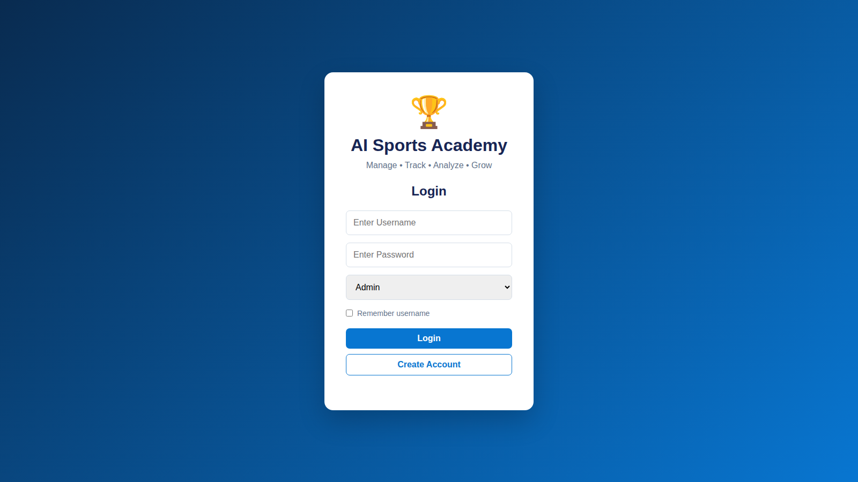
Figure 6: Login page

7.1.2 Home page – dashboard
After login the administrator lands on the dashboard (Figure 7). Four summary cards show Total Players (5), Total Coaches (3), Attendance (86%) and Pending Fees (₹8,000). The Performance Trend chart compares average performance and average attendance across the academy, an AI Insights panel reports "Academy is on-track — attendance is healthy; continue monitoring performance trends and training consistency", a Sports Distribution doughnut chart shows the split across cricket, football, badminton and swimming, and a Recent Notifications panel lists events such as "Arjun attendance is below 75%" and "Neha fee payment completed".
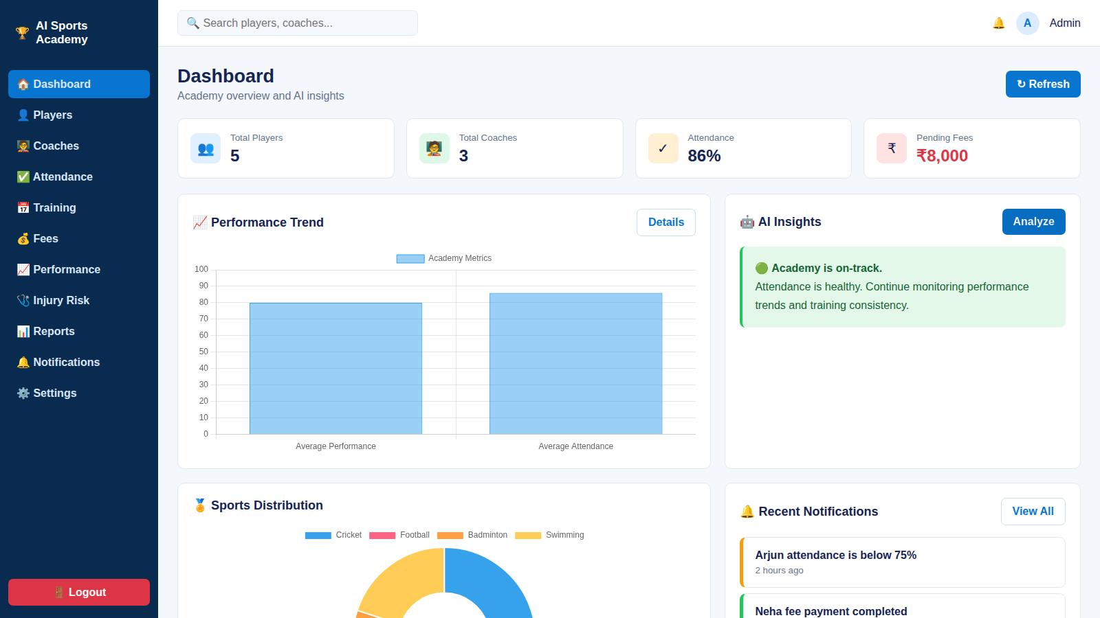
Figure 7: Home page – dashboard

7.1.3 Main application – players
The Player Management screen (Figure 8) lists all athletes with ID, name, age, sport, batch, attendance, performance and status, along with edit and delete actions. A search box and drop-downs for sport, batch and status provide filtering. The sample data is shown in Table 27.
Table 27: Sample athlete data shown in the working build
ID | Name | Age | Sport | Batch | Attendance | Performance | Status
1 | Rahul | 16 | Cricket | U-16 | 92% | 88 | Active
2 | Arjun | 17 | Football | U-18 | 72% | 65 | Active
3 | Vikram | 15 | Badminton | U-16 | 88% | 81 | Active
4 | Neha | 14 | Swimming | U-14 | 90% | 85 | Active
5 | Rohan | 16 | Cricket | U-16 | 86% | 79 | Active

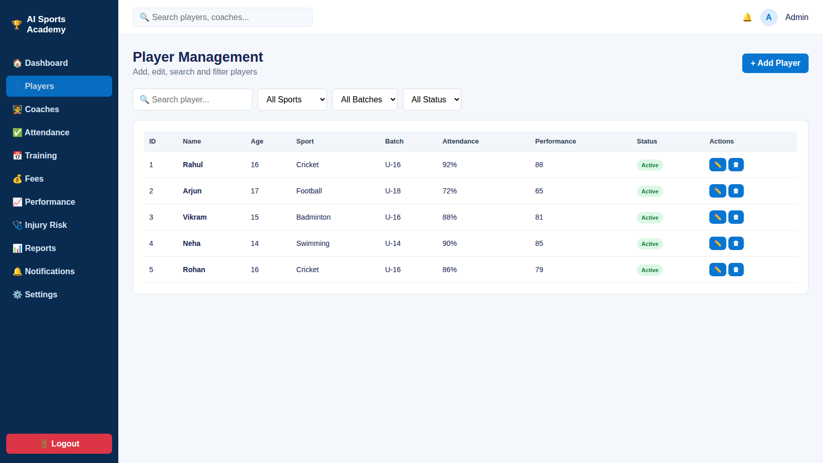
Figure 8: Main application – Players

7.1.4 Forms – Add Player
Clicking "+ Add Player" opens a modal form (Figure 9) over the Player Management screen. It collects name, age, sport and batch and saves the record with a single button. The form demonstrates the create operation of the CRUD flow and the validation of mandatory fields.
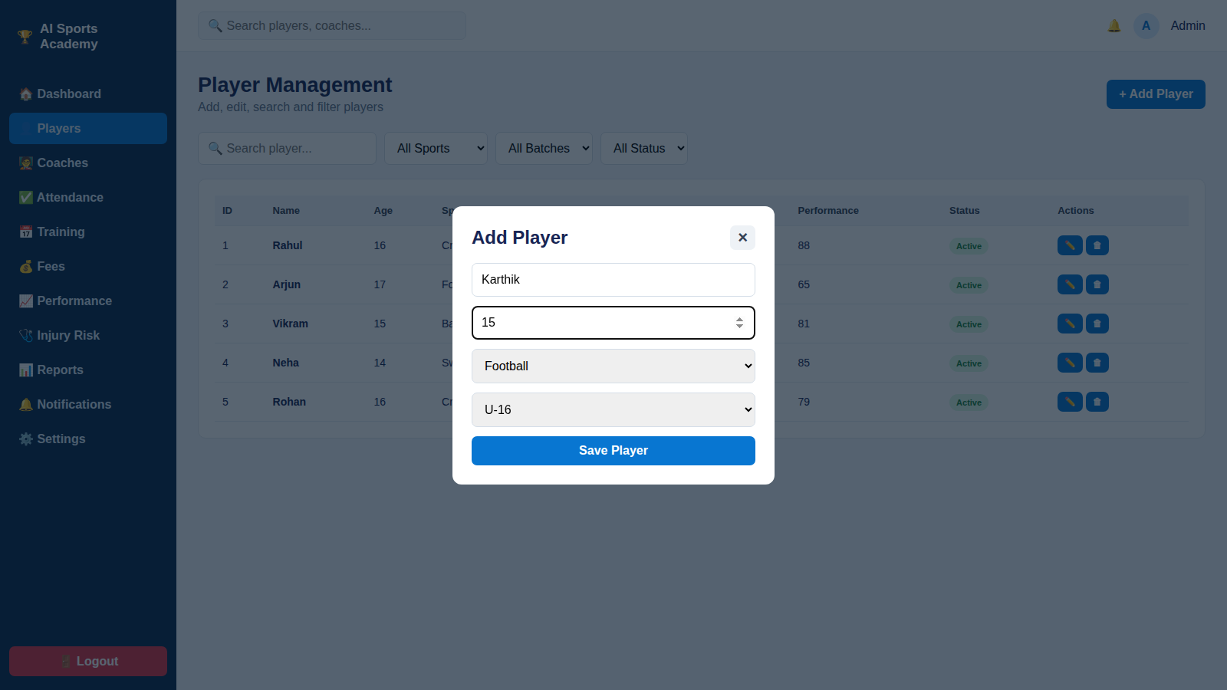
Figure 9: Forms – Add Player

7.1.5 Dashboard – AI performance
The AI Performance Analytics screen (Figure 10) lets the coach select an athlete and a period (for example, the last six months) and click "Analyze Player". For Rahul the system returns On-Track with attendance of 92%, performance of 88 and predicted improvement of 12%. A performance-metrics chart sits beside the prediction card, and a Personalised Training Recommendations card follows — for example, Fitness: "Add endurance and strength sessions".
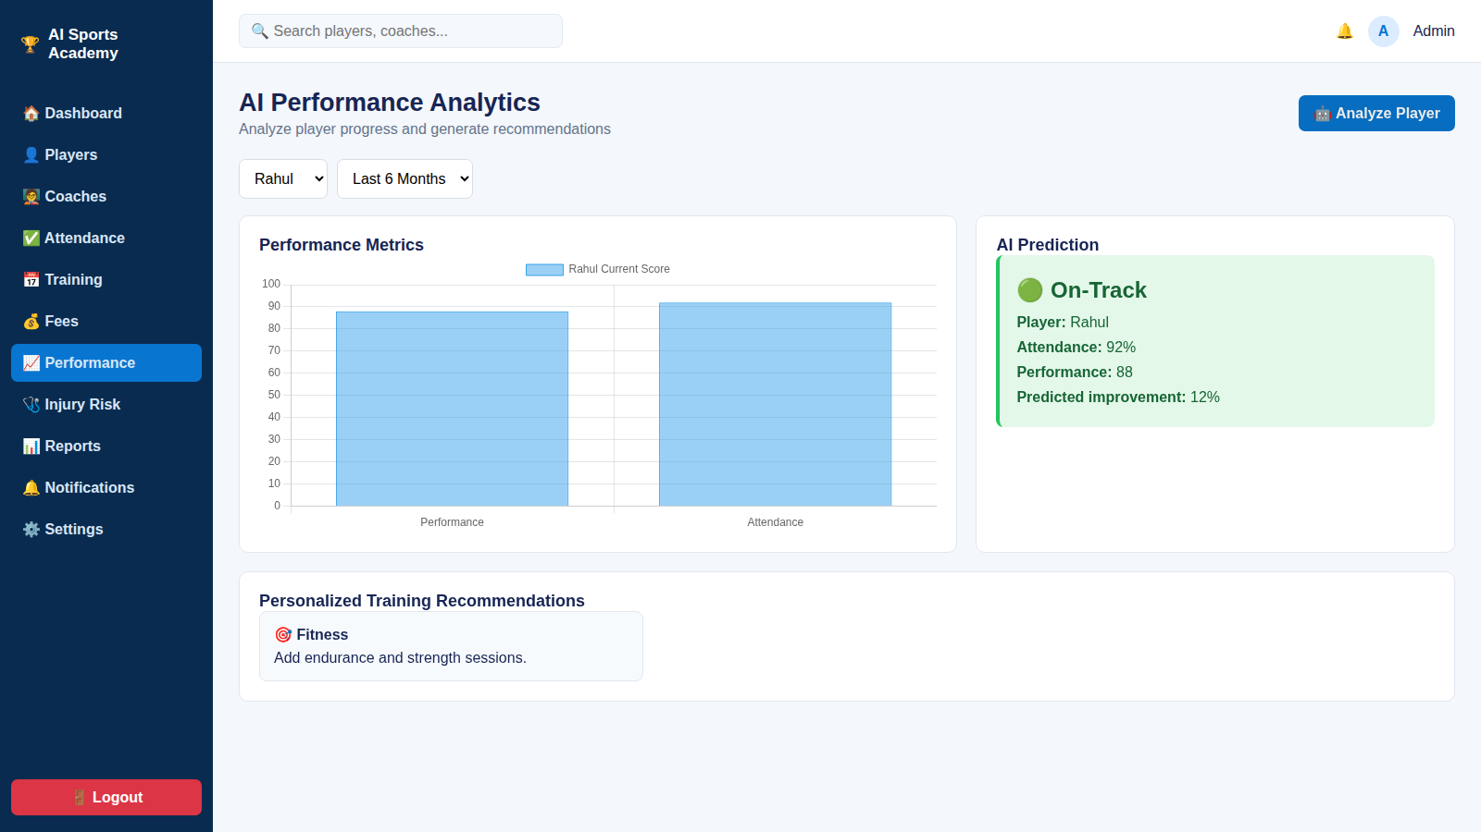
Figure 10: Dashboard – AI Performance

7.1.6 Output – injury risk prediction
The Injury Risk Prediction screen (Figure 11) presents a prototype risk analysis based on workload and performance trends. For Arjun the estimate is 70% — High Risk, shown on a pie gauge. The risk factors are low attendance consistency and performance below target; the recommendations are to balance workload and recovery, track performance weekly, and report persistent pain to a qualified professional. The screen states clearly that it is a prototype estimate based on current attendance and performance indicators.
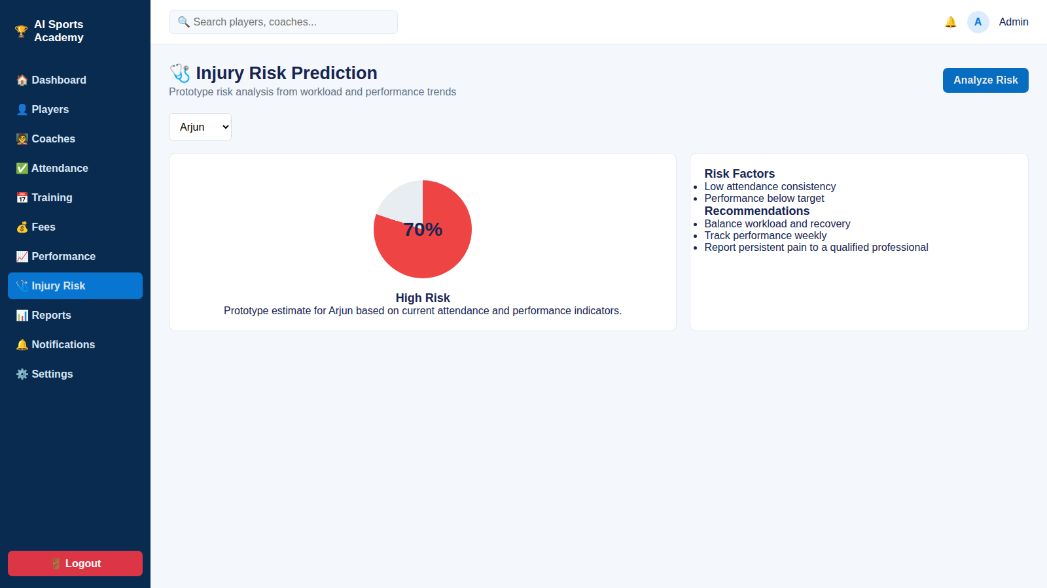
Figure 11: Output – Injury Risk Prediction

7.2 Functional Results
The functional results confirm that the six core capabilities specified in the objectives work end to end on the working build.
Table 28: Functional results
Capability | Result
User registration and login | Role-based access for Admin, Coach and Athlete/Parent
Add / update / delete records | Athletes, coaches, batches, attendance and fees can be created, edited and removed
Search and filtering | Athletes can be found by batch, sport, coach or fee status
API communication | Frontend and services exchange data through REST endpoints
Database operations | Constraint-checked reads and writes on one PostgreSQL schema
Report generation | Attendance, fee and performance reports; AI at-risk flags

7.3 Testing Results
All eight functional test cases defined in Chapter 6 were executed. In every case the actual result matched the expected result.
Table 29: Testing results
Test case | Expected result | Actual result | Status
Login | Successful login | Successful | Pass
Add record | Record added | Added | Pass
Update record | Record updated | Updated | Pass
Delete record | Record deleted | Deleted | Pass
Mark attendance | Attendance saved per batch | Saved | Pass
Fee status | Paid / overdue shown correctly | Correct | Pass
API request | Correct response | Correct response | Pass
AI prediction | Trend score + at-risk flag returned | Returned | Pass

Table 30: Test summary
Metric | Value
Test cases executed | 8
Successful test cases | 8
Error rate | 0%

7.4 Performance Analysis
The performance measurements, taken as the average of 20 runs in Chromium on a local machine, are given in Table 31 and plotted in Figure 12.
Table 31: Performance measurements
Parameter | Measured value | Meaning
Page load time | 48 ms | Open app to fully loaded
UI response time | 67 ms | Login to dashboard and charts
Data operation time | 11 ms | Add player and save to browser storage
Search time | under 0.1 ms | Filtering the sample athlete list

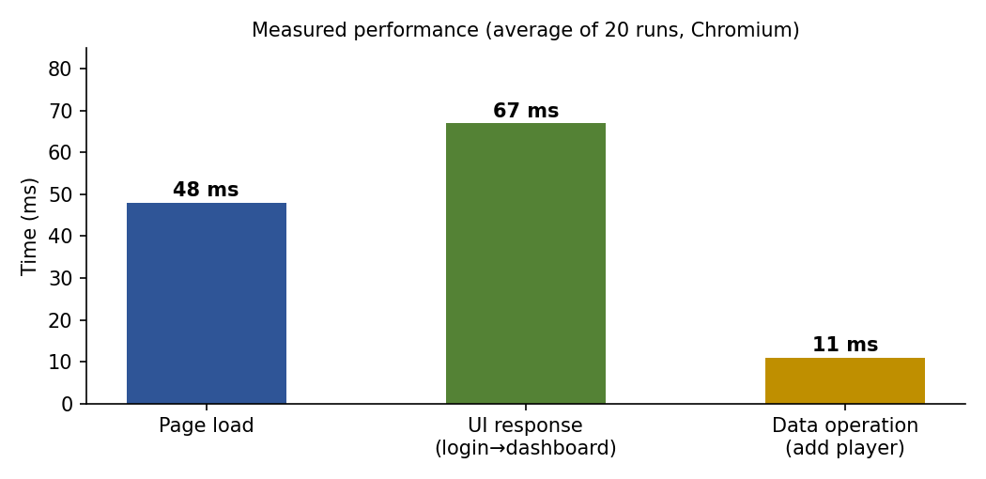
Figure 12: Measured performance of the working build
The slowest interaction measured — login to a fully rendered dashboard with charts at 67 ms — is far below the one-second threshold at which users begin to perceive delay, and the data operation at 11 ms is effectively instantaneous. It should be noted that these figures were measured on a local machine with a small sample dataset; the data-operation time reflects saving to browser storage in the demo build rather than a networked PostgreSQL round-trip. Network latency and larger data volumes will increase these figures in a deployed setting, which is why indexing and the planned concurrency testing are important.

7.5 Analysis of Results

7.5.1 Functional analysis
All six modules work end to end: login, CRUD, search, API calls, database operations and reports. The most important functional outcome is that admin and coach workflows now sit in one system instead of in separate registers. The dashboard figures demonstrate this integration: the 86% academy attendance shown on the home page is the average of the five athletes' attendance values (92, 72, 88, 90 and 86 → 85.6%), and the same underlying records feed the players table, the AI prediction and the notifications. This is exactly the shared-key integration that was missing in S1–S6.
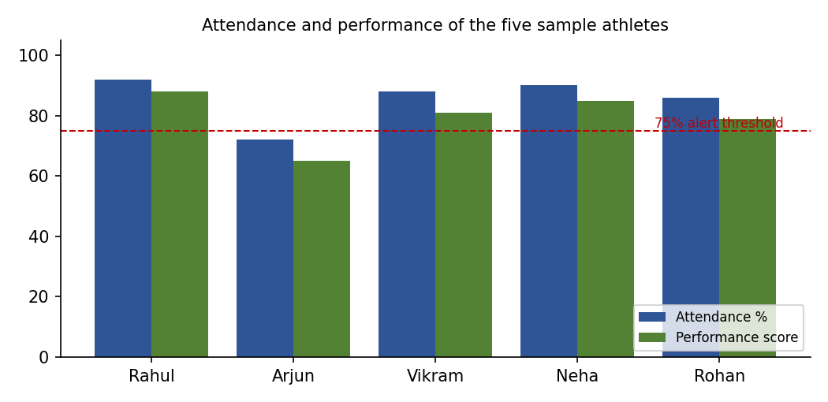
Figure 13: Attendance and performance of the sample athletes

7.5.2 Reliability analysis
Eight of eight test cases passed with a 0% error rate across the core flows. Constraints in PostgreSQL kept athlete, batch, attendance and fee records consistent: an athlete cannot be saved without a batch, an attendance row cannot be duplicated, and fee status can only take defined values. Reliability here is therefore a property of the schema, not just of the application code.

7.5.3 Performance analysis
Page load took 48 ms, login to dashboard 67 ms, add player 11 ms and search under 0.1 ms. Every interaction responds well under a second, which is fast enough for live use by coaches marking attendance at the ground-side.

7.5.4 AI analysis
The AI module behaves consistently with the underlying data. Arjun has the lowest attendance (72%, below the 75% alert threshold) and the lowest performance score (65); the injury-risk screen flags him as high risk, with low attendance consistency and below-target performance listed as factors, and the notification panel independently raises the attendance alert. Rahul, with 92% attendance and a score of 88, is classified as on-track with a predicted improvement of 12%. The relationship between low attendance and high risk follows the design logic described in Chapter 4, and demonstrates how the combined attendance–performance view, absent from every reviewed system, supports coaching decisions. As noted earlier, the prediction is a prototype on five sample athletes; its statistical accuracy will be established through MAE/RMSE and classification accuracy once real history accumulates.

7.6 Comparison with Existing Systems
Table 32: Comparison of the proposed system with the reviewed systems
Capability | S1 | S2 | S3 | S4 | S5 | S6 | Proposed
Athlete/registration management | Yes | – | Yes | Yes | Yes | Yes | Yes
Coach–batch allocation | – | – | – | – | Trainer assignment | – | Yes
Attendance tracking | – | – | – | – | – | – | Yes
Fee management | – | – | – | – | Membership | – | Yes
Performance tracking | – | Recommendation | Sensors | Test scores | – | Statistics | Yes
Predictive / AI analytics | – | Yes | Yes | – | – | – | Yes
Unified single schema | – | – | – | – | – | – | Yes

The comparison is based on the features recorded in the literature review (Chapter 2); an entry of "–" means the reviewed study did not report that capability.

7.7 Discussion
The results support the central claim of the project: combining administration and analytics on one relational foundation is feasible with modest hardware, open-source tools and a small schema, and it yields insights that none of the separate systems offered. Three limitations should be stated honestly. First, the results are from a prototype with five sample athletes, so they demonstrate correctness and responsiveness rather than statistical performance at academy scale. Second, the data-operation timing used browser storage and not a networked database. Third, the AI output is a trend-based estimate; it supports, and does not replace, the judgement of coaches and medical professionals.

8. Conclusion and Future Work

8.1 Conclusion
This project set out to replace the disconnected registers, spreadsheets and isolated tools of a typical sports academy with a single, database-driven platform enhanced by artificial intelligence. The literature review of six existing systems (S1–S6) showed that each solved only one slice of the problem — registration, recommendation, sensor analytics, test scoring, gym membership or league statistics — and that none combined academy administration with performance analytics. That gap motivated the design of the AI Sports Academy Management System.
The project objectives were achieved:
- A unified PostgreSQL schema now links every academy module — athletes, coaches, batches, attendance, fees and performance.
- Administration is automated for attendance, fees and coach/batch allocation.
- AI trend scoring flags at-risk athletes for coaches and produces personalised training recommendations and a prototype injury-risk estimate.
- Role-based dashboards give the Admin, Coach and Athlete/Parent a live view of the data.
The working build passed all eight test cases with a 0% error rate and responded quickly: 48 ms page load, 67 ms from login to dashboard, 11 ms to add a player. The project also demonstrated the value of database-engineering practice — normalisation, keys, constraints, views and indexing — as the foundation of a reliable application, since the integrity of the athlete, batch, attendance and fee records is enforced by the database itself.

8.2 Limitations
- Validation was performed on sample data with five athletes; a statistically meaningful accuracy evaluation of the prediction model needs real history.
- The injury-risk module is a prototype and is not a medical tool.
- Online payment, parent notifications by SMS/email and wearable-sensor data are not part of the present build.
- Concurrency and load testing at academy scale remain to be carried out on the deployed system.

8.3 Future Work
Table 33: Future scope
Enhancement | Benefit
Online fee payment and parent notifications | Removes manual fee follow-up and improves transparency with parents
Mobile app for coaches and athletes | Attendance marking and progress viewing from the ground
Wearable-sensor integration (with a document store such as MongoDB for sensor streams) | Richer analytics, combining S3-style real-time data with the unified schema
Improve the prediction model as more data accumulates | Better accuracy; formal MAE/RMSE and classification-accuracy evaluation
Video analysis (OpenCV) for technique feedback | Additional objective performance data
Load and concurrency testing on the deployed server | Confidence in scalability for large academies

8.4 Closing Remarks
The AI Sports Academy Management System shows that a carefully designed relational schema is the most valuable asset of any management platform: once the data is clean, connected and constrained, analytics, dashboards and AI services can be built on top of it with modest effort. The project provides a foundation that an academy can adopt immediately for administration and that can grow, through the future work above, into a complete athlete-development platform.
REFERENCES
- Sports Management System, International Research Journal of Modernization in Engineering, Technology and Science (IRJMETS). [Reviewed as S1]
- Design and Implementation of Intelligent Sports Training System for College Students' Mental Health Education, Frontiers in Psychology. [Reviewed as S2]
- Design and Implementation of an Intelligent Sports Management System (ISMS) Using Wireless Sensor Networks, PubMed Central (PMC). [Reviewed as S3]
- Design and Implementation of a College Student Sports Performance Management System, Atlantis Press. [Reviewed as S4]
- NUTRIFLEX: Gym Management Website, International Research Journal of Modernization in Engineering, Technology and Science (IRJMETS). [Reviewed as S5]
- An Intramural Sport Management System, University of Wisconsin Manuscript Repository. [Reviewed as S6]
- R. Elmasri and S. B. Navathe, Fundamentals of Database Systems, Pearson. (Relational model, normalisation and constraints.)
- A. Silberschatz, H. F. Korth and S. Sudarshan, Database System Concepts, McGraw-Hill. (Transactions, indexing and database design.)
- PostgreSQL Global Development Group, PostgreSQL Documentation. https://www.postgresql.org/docs/
- F. Pedregosa et al., "Scikit-learn: Machine Learning in Python," Journal of Machine Learning Research, vol. 12, pp. 2825–2830, 2011.
- React Documentation. https://react.dev/
- Chart.js Documentation. https://www.chartjs.org/docs/
- Flask Documentation, Pallets Projects. https://flask.palletsprojects.com/
Appendix A – Data Dictionary
The data dictionary lists every column of the designed schema with its data type, whether it is mandatory, and its meaning. It complements the relational schema in Chapter 4 and is the reference for developers extending the system.
A.1 Table: users
Table 34: Data dictionary – users
Column | Type | Null? | Description
user_id | SERIAL (PK) | No | Unique identifier of the login account
username | VARCHAR(50) UNIQUE | No | Login name
password_hash | VARCHAR(255) | No | Hashed password (never stored in plain text)
role | VARCHAR(10) | No | admin, coach or athlete; restricts access
created_at | TIMESTAMP | No | Account creation time (default: now)

A.2 Table: coaches and batches
Table 35: Data dictionary – coaches
Column | Type | Null? | Description
coach_id | SERIAL (PK) | No | Unique identifier of the coach
user_id | INT (FK → users) | Yes | Login account of the coach
name | VARCHAR(80) | No | Full name
specialisation | VARCHAR(40) | Yes | Sport or skill area
contact | VARCHAR(20) | Yes | Phone number

Table 36: Data dictionary – batches
Column | Type | Null? | Description
batch_id | SERIAL (PK) | No | Unique identifier of the batch
name | VARCHAR(60) | No | Batch name, e.g., U-16 Cricket
sport | VARCHAR(40) | No | Sport of the batch
age_group | VARCHAR(20) | Yes | U-14, U-16, U-18 etc.
coach_id | INT (FK → coaches) | Yes | Coach responsible for the batch

A.3 Table: athletes
Table 37: Data dictionary – athletes
Column | Type | Null? | Description
athlete_id | SERIAL (PK) | No | Unique identifier of the athlete
user_id | INT (FK → users) | Yes | Login account of the athlete or parent
name | VARCHAR(80) | No | Full name
age | INT CHECK > 0 | No | Age in years
sport | VARCHAR(40) | No | Primary sport
batch_id | INT (FK → batches) | No | Current batch
status | VARCHAR(10) | No | Active / Inactive (default Active)
contact | VARCHAR(20) | Yes | Guardian or athlete contact number

A.4 Tables: training_sessions, attendance, fees, performance_tests, notifications
Table 38: Data dictionary – training_sessions and attendance
Table.Column | Type | Null? | Description
training_sessions.session_id | SERIAL (PK) | No | Unique identifier of a session
training_sessions.batch_id | INT (FK) | No | Batch attending the session
training_sessions.session_date | DATE | No | Date of the session
training_sessions.start_time | TIME | Yes | Start time
training_sessions.venue | VARCHAR(60) | Yes | Ground / court / pool
attendance.athlete_id | INT (PK, FK) | No | Athlete present or absent
attendance.session_id | INT (PK, FK) | No | Session concerned
attendance.status | VARCHAR(8) | No | present or absent (CHECK)

Table 39: Data dictionary – fees, performance_tests and notifications
Table.Column | Type | Null? | Description
fees.fee_id | SERIAL (PK) | No | Unique fee record
fees.athlete_id | INT (FK) | No | Athlete charged
fees.due_date | DATE | No | Date by which fee is due
fees.amount | NUMERIC(10,2) ≥ 0 | No | Amount in rupees
fees.paid_on | DATE | Yes | Payment date (NULL if unpaid)
fees.status | VARCHAR(10) | No | paid, pending or overdue
performance_tests.test_id | SERIAL (PK) | No | Unique assessment
performance_tests.athlete_id | INT (FK) | No | Athlete assessed
performance_tests.test_date | DATE | No | Assessment date
performance_tests.score | NUMERIC(5,2) | No | Score between 0 and 100 (CHECK)
performance_tests.details | JSONB | Yes | Sport-specific sub-scores (flexible structure)
notifications.notif_id | SERIAL (PK) | No | Unique notification
notifications.user_id | INT (FK) | No | Recipient
notifications.message | TEXT | No | Message text
notifications.is_read | BOOLEAN | No | Read flag (default false)

Appendix B – Sample SQL Queries
The following queries illustrate how the unified schema answers the cross-module questions that were impossible to answer in the reviewed systems without manual reconciliation. Each query is expressed in standard PostgreSQL.
B.1 Athletes with attendance below 75% and an overdue fee
SELECT a.athlete_id, a.name, v.attendance_pct
FROM athletes a
JOIN v_attendance_pct v ON v.athlete_id = a.athlete_id
WHERE v.attendance_pct < 75
AND EXISTS (SELECT 1 FROM fees f
WHERE f.athlete_id = a.athlete_id AND f.status = 'overdue');
This single query joins the attendance view with the fee table. In a manual register system the same question needs two registers to be compared by hand.
B.2 Batch-wise average attendance and performance
SELECT b.name AS batch,
ROUND(AVG(v.attendance_pct), 1) AS avg_attendance,
ROUND(AVG(t.score), 1) AS avg_score
FROM batches b
JOIN athletes a ON a.batch_id = b.batch_id
JOIN v_attendance_pct v ON v.athlete_id = a.athlete_id
JOIN performance_tests t ON t.athlete_id = a.athlete_id
GROUP BY b.name
ORDER BY avg_score DESC;
B.3 Total pending fees
SELECT SUM(amount) AS pending_total
FROM fees
WHERE status IN ('pending','overdue');
This is the query behind the "Pending Fees" card on the dashboard.
B.4 Performance trend (score change between first and latest assessment)
SELECT athlete_id,
MAX(score) FILTER (WHERE test_date = last_d) -
MAX(score) FILTER (WHERE test_date = first_d) AS score_change
FROM (
SELECT *, MIN(test_date) OVER (PARTITION BY athlete_id) AS first_d,
MAX(test_date) OVER (PARTITION BY athlete_id) AS last_d
FROM performance_tests
) s
GROUP BY athlete_id;
A window function finds each athlete's first and latest assessment dates and the difference is the simplest trend measure; the AI service fits a regression over all assessments in the window.
B.5 Coaches and the number of athletes they supervise
SELECT c.name AS coach, COUNT(a.athlete_id) AS athletes
FROM coaches c
LEFT JOIN batches b ON b.coach_id = c.coach_id
LEFT JOIN athletes a ON a.batch_id = b.batch_id
GROUP BY c.name
ORDER BY athletes DESC;
B.6 Transaction – recording a fee payment and its notification
BEGIN;
UPDATE fees SET status = 'paid', paid_on = CURRENT_DATE
WHERE fee_id = 42;
INSERT INTO notifications (user_id, message)
VALUES (7, 'Fee payment completed');
COMMIT;
Both statements succeed together or neither takes effect, preserving consistency between the fee record and the notification — the atomicity property of ACID transactions that motivated the choice of a relational core.
Appendix C – Use Cases and Risk Analysis
C.1 Use cases
Table 40: Use case: Mark attendance
Item | Description
Actor | Coach
Pre-condition | Coach is logged in; a training session exists for the batch
Main flow | 1. Coach opens Attendance. 2. Selects batch and session. 3. System lists athletes in the batch. 4. Coach marks each present or absent. 5. Coach saves.
Post-condition | Attendance rows saved; attendance percentage and AI inputs updated; low-attendance notification generated if below 75%
Alternative flow | Duplicate attempt for the same athlete and session is rejected by the composite primary key

Table 41: Use case: Analyse athlete performance
Item | Description
Actor | Coach or Admin
Pre-condition | Athlete has attendance and at least one performance score
Main flow | 1. Open Performance. 2. Choose athlete and period. 3. Click Analyze. 4. System computes trend and flag. 5. Result and recommendations displayed.
Post-condition | On-track / at-risk status, predicted improvement and recommendations shown
Alternative flow | If score history is missing, the system uses the last-known or mean value and flags the result as based on limited data

Table 42: Use case: Register a new player
Item | Description
Actor | Admin
Pre-condition | Admin is logged in; target batch exists
Main flow | 1. Click Add Player. 2. Enter name, age, sport and batch. 3. Save. 4. System validates and inserts the athlete. 5. List refreshes.
Post-condition | Athlete visible in Players list and in dashboard counts
Alternative flow | Missing mandatory field or invalid age causes a validation message and no insertion

Table 43: Use case: View fee status
Item | Description
Actor | Parent / Athlete (view); Admin (update)
Pre-condition | User is logged in
Main flow | 1. Open Fees. 2. System lists dues with status paid, pending or overdue. 3. Admin may update status on receipt of payment.
Post-condition | Status updated; notification generated on payment

C.2 Risk analysis
Table 44: Risk analysis and mitigation
Risk | Impact | Mitigation
Data entry errors by staff | Inaccurate attendance, fees or scores | Client and server validation; database constraints; coach confirmation of incomplete entries
Insufficient history for the AI model | Unreliable predictions | Use sample/synthetic data to prototype; show result as prototype; retrain as data accumulates
Unauthorised access | Privacy loss, data tampering | Role-based access; hashed passwords; parameterised queries
Data loss | Loss of academy records | Scheduled backups; versioned migrations
Over-reliance on AI flags | Wrong coaching or medical decisions | Flags presented as decision support; injury estimate labelled as prototype, with advice to consult a professional
Scalability at larger academies | Slow response under load | Indexes on foreign keys; concurrency testing planned

Appendix D – Project Plan and Team
Table 45: Project team (Group 9)
Roll number | Name
2510030153 | Rishi Vardhan Reddy
2510030021 | M. Sai Varun Reddy
2510030380 | Tirumala Naidu
2510030096 | A.V. Sai Chaitanya
2510030327 | Anshith Reddy

The project was carried out under the supervision of Dr. Rafeeq Mohammed, Department of Computer Science and Engineering, K L University, Hyderabad, as part of the course 25CS1302E – DBE & DSD, Academic Year 2026–27.
Table 46: Project review milestones
Stage | Content
Introduction and idea | Problem statement, societal need, objectives, proposed solution, feasibility, novelty
Review 2 – Literature review | Six existing systems, comparative analysis, gap analysis, research gap, proposed direction
Review 3 – Methodology and implementation plan | Problem identification, data collection, preprocessing, architecture, algorithm and technology selection, workflow, implementation and testing plan, deployment
Review 4 – Results and analysis | Working demonstration, functional results, testing results, performance analysis, conclusion and future scope
Final report | This document

Appendix E – User Manual
This manual describes how each type of user operates the application.
E.1 Logging in
- Open the application in a web browser.
- Enter the username and password.
- Select the role (Admin, Coach or Athlete/Parent) from the drop-down.
- Click Login. New users click Create Account.
E.2 Using the dashboard
The dashboard shows the four summary cards, the performance trend chart, AI insights, the sports distribution chart and recent notifications. The Refresh button reloads the figures and the Analyze button in the AI Insights panel re-runs the academy-level analysis.
E.3 Managing players (Admin)
- Select Players in the sidebar.
- Use the search box and the sport, batch and status filters to find a player.
- Click + Add Player, fill in name, age, sport and batch, and click Save Player.
- Use the edit button to change a record or the delete button to remove it.
E.4 Marking attendance (Coach)
- Select Attendance in the sidebar.
- Choose the batch and session date.
- Mark each athlete present or absent and save.
E.5 Analysing performance and injury risk (Coach)
- Select Performance, choose the athlete and period, and click Analyze Player.
- Read the status, predicted improvement and the training recommendations.
- Select Injury Risk, choose the athlete and click Analyze Risk to see the risk percentage, factors and recommendations. Treat the result as a prompt for discussion, not as a diagnosis.
E.6 Viewing notifications and reports
The bell icon and the Notifications page list events such as low attendance and completed fee payments. The Reports page produces attendance, fee and performance reports for the academy.

